

PROJECT REPORT

TASK FORCE

CONTENTS

1. Definition Of Problem
2. Requirements Analysis
3. Design Phase
4. Architecture of website
5. Evaluation/Testing
6. Project Tracking and Monitoring Activities
7. Documentation Section
8. Source code
9. User Guide

1.Definition of problem

“Soccer ” is a soccer leagues website to be designed as a web design

A soccer website may encounter various problems, such as slow loading times, broken links, outdated information, navigation difficulties, or inadequate search functionality. A problem-solving approach involves analyzing these issues and implementing appropriate strategies to resolve them.

Additionally, problem-solving on a soccer website extends beyond technical aspects. It also encompasses identifying user pain points and addressing them through intuitive design choices, clear communication channels for support or inquiries, and relevant content that caters to different levels of interest or expertise

2.Requirements Analysis

* List of inputs to the system

In this website “soccer”, Example of inputs would be contact us,tournament,Clubs,leagues and so on...

* List of outputs expected from the system

In this website Soccer ,Example of outputs would be player Statistics Data,Feedbacks

* Hardware and Software requirements for implementing the project

# **Hardware**

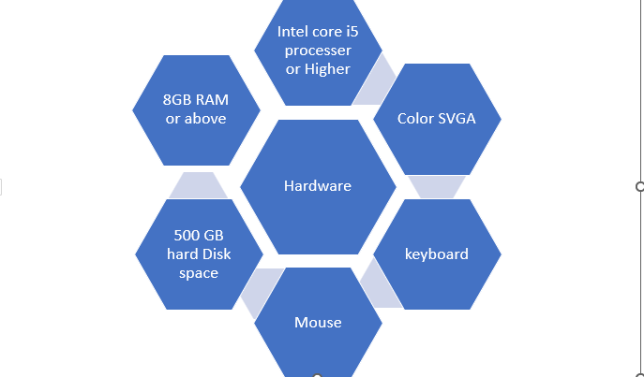

# **Software**



* Customer’s acceptance of the criteria for the project

The acceptance criteria could be following

1. Current Live score
2. User Favourite Player Biographics
3. Upcoming schedule

3.Design phase

Design phase involves the preparation of the blueprint of the proposed system

* Designing The GUI Standard

For “soccer” you must have plan and design the user interface using **canva**.Multiple pages must be created and linked to each other.Each of these pages or forms Should have a consistent look with respect to appearance and theme used. The font style, color of the label, design and appearance of the command buttons,the appearance of header and footer and the design size of control,such as checkbox or textbox should be consistent through the feedback and contact us page

* Designing the database
* Designing the process modules
* Designing Coding standard

4. Architecture of Website

* Data Flow Diagram (DFD)
* Flow chart
* Database design
* Entity relationship (ER)diagram

5. Evaluation/Testing

6. Project Tracking and Monitoring

7. Documentation section

8.Source code

9. User Guide